PES1UG20CS494 SEC = I DATE = 26-09-2022

Task-I: Use INSERT/SELECT/UPDATE queries for the following tasks:

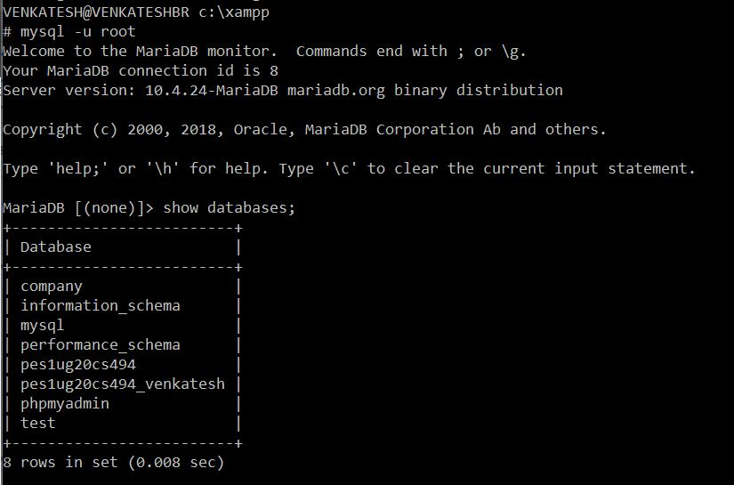

1. Insert the shared data into the respective tables using appropriate insert query. • Show the usage of INSERT and LOAD DATA INFILE commands explicitly

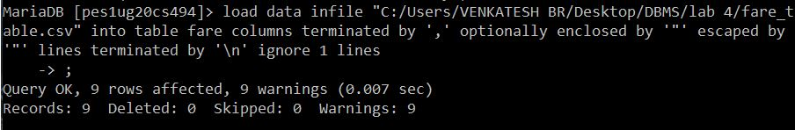

   
2. Calculate and update age attribute in User Table.

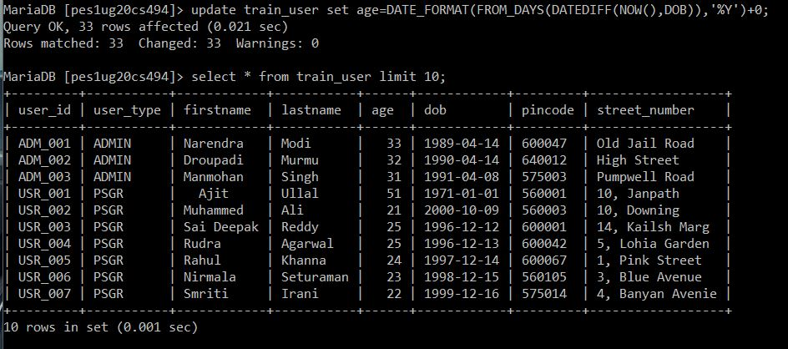

3. Display all the route information whose distance falls in a range from 70 to 150 km.

   
4. Display the train route information which are run between Chennai and Sholingur.

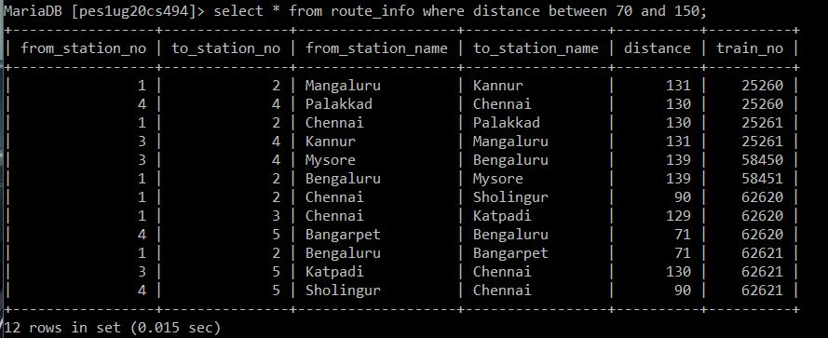

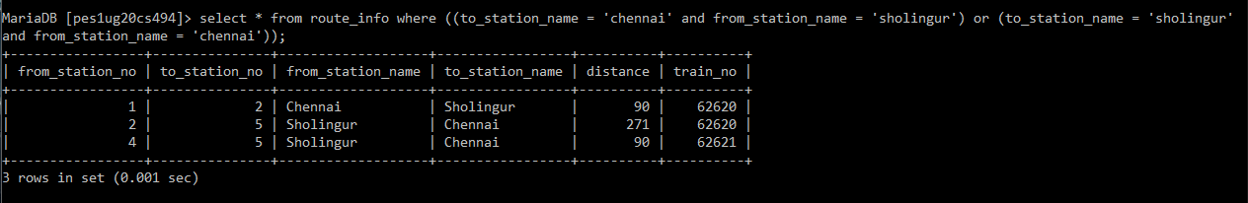

5. Display the train details whose type is not mail.

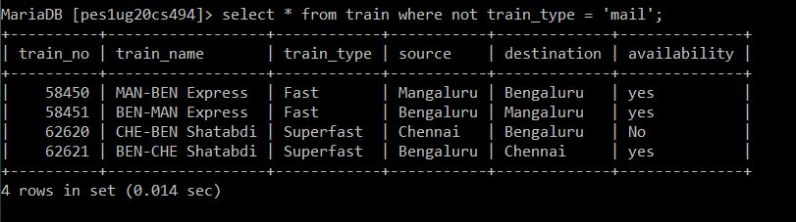

6. Display the train name which goes to Chennai from Bangalore.

 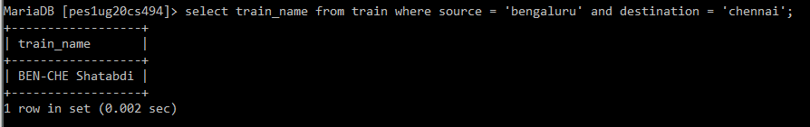

7. Display the list of trains starting from Chennai after 8:00.

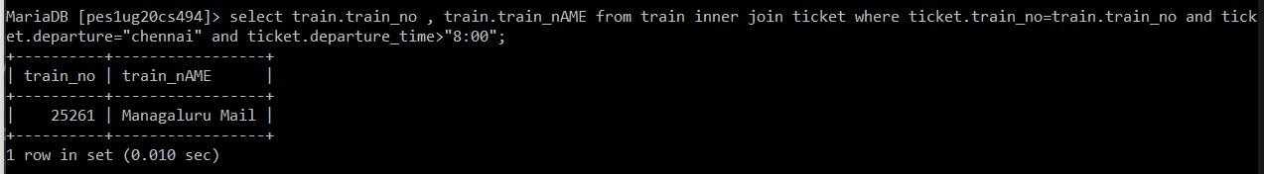

8. Display the list of users who are born between 1980 to 1990.

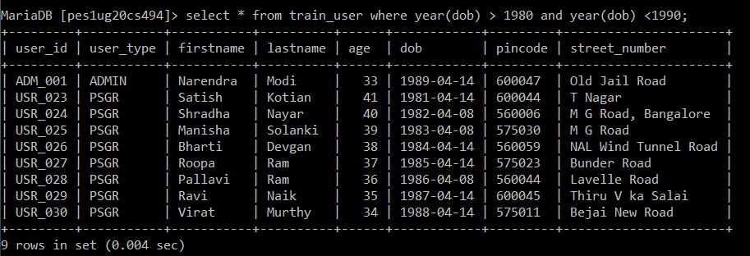

9. Display the train users whose name starts with the letter ‘S’.

   
10. Find the availability of I Class compartment of the train number 62621.

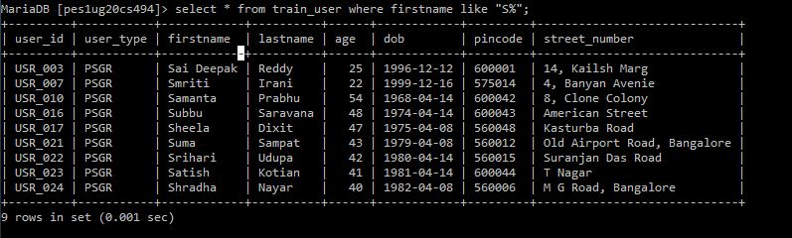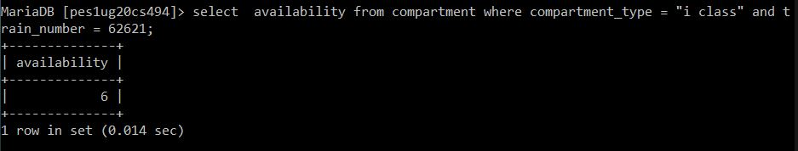

11. Find the PNR and Transaction ID of the users who made payment via Union Bank.

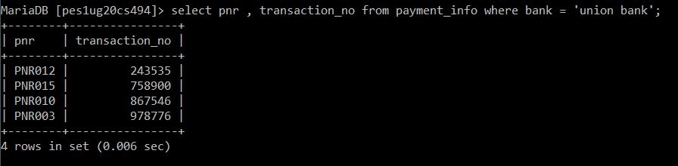

Task-II: Use DCL and TCL statements for the following:

1. Grant privileges on different tables to users and observe the effect.

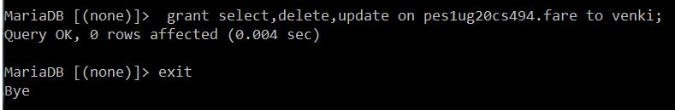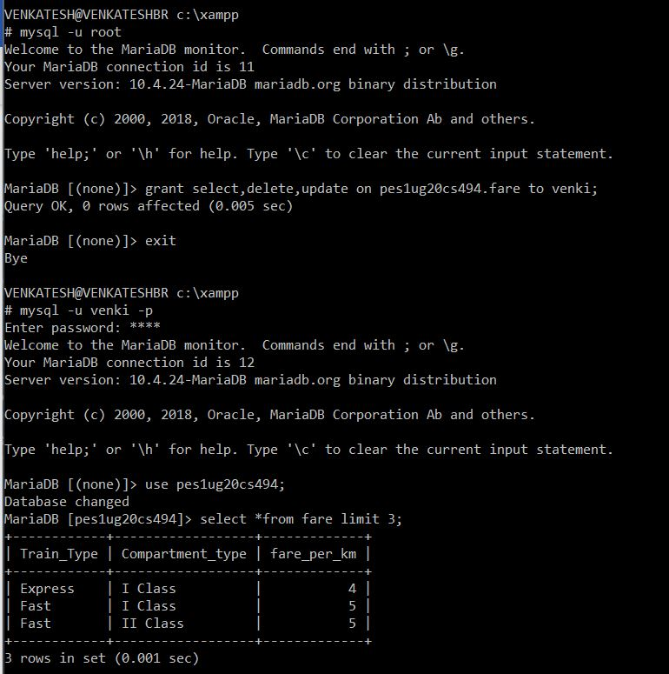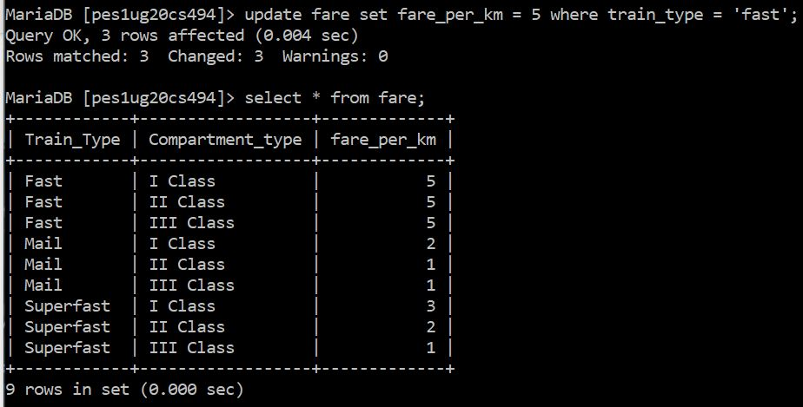

1. Revoke UPDATE & DELETE privileges on any tables and observe the effect if any deletion/updation is performed

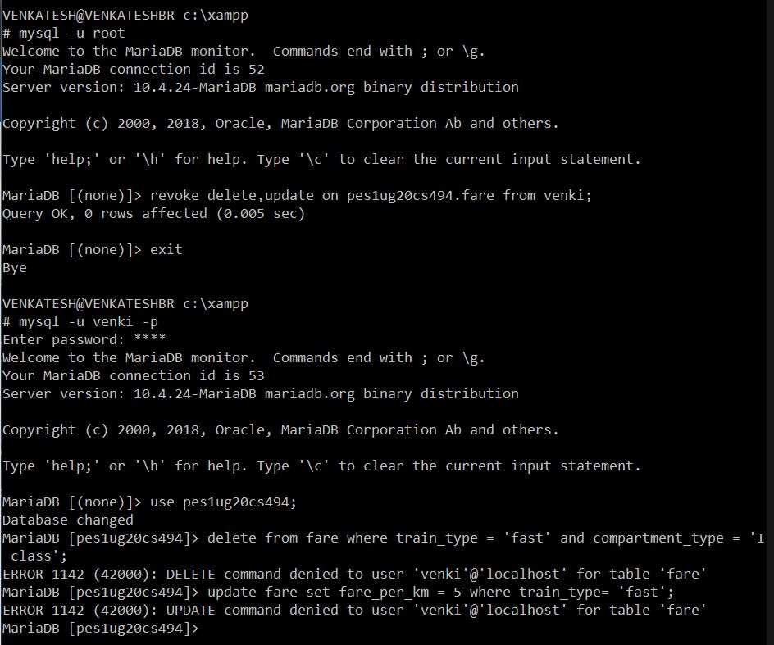

1. Create different save points and perform some insert/update/delete operations. Observe the effect of commit & rollback operations and release any created savepoints.

